Council Assessment Report
Panel Reference | PPS-2013HCC-16
DA number | DA/1284/2013
LGA | Lake Macquarie City Council
Proposed development | Subdivision consisting of 66 residential lots, three future development lots and 3 conservation lots plus roads, drainage and associated infrastructure.
Permissibility | Permissible under Lake Macquarie Local Environmental Plan 2004 and Lake Macquarie Local Environmental Plan 1984.
Street address | 9A Myall Road, Garden Suburb  69 and 82 Myall Road, Cardiff
Zoning | Lake Macquarie Local Environmental Plan 1984  1A Rural  2A Residential  2B Residential  3C Neighbourhood Business  5C Special Uses (Proposed Local Road Reservation)  6A Open Space (Public Recreation)  6B Open Space (Special Recreation)  6C Open Space (Local Reservation)  Lake Macquarie Local Environmental Plan 2004  6(1) Open Space  7(2) Conservation (Secondary)
Applicant/Owner | Applicant: Elton Consulting  Owner: New South Wales land and Housing Corporation (Landcom)
Date of DA lodgement | 26 August 2013
Number of submissions | 37 submissions (all in objection)  Notified on two occasions:  - 9 September 2013 to 14 October 2013 (30 submissions)  - 23 May 2018 to 13 June 2018 (seven submissions)
Integrated development | Mine Subsidence Compensation Act 1961  Rural Fires Act 1997  Water Management Act 2000
External referrals | Ausgrid  TransGrid
Recommendation | Approval, subject to conditions of consent
Regional Development Criteria (Schedule 7 of the SEPP (State and Regional Development) 2011 | Crown development with a Capital Investment Value over $5 million  CIV $5,115,000
List of all relevant s4.15(1)(a) matters | - Environmental Planning and Assessment Act 1979  - Environmental Planning and Assessment Regulation 2000  - Coal Mine Subsidence Compensation Act 2017  - Rural Fires Act 1997  - Water Management Act 2000  - State Environmental Planning Policy No. 19 – Bushland in Urban Areas  - State Environmental Planning Policy No. 44 - Koala Habitat Protection  - State Environmental Planning Policy No. 55 – Remediation of Land  - State Environmental Planning Policy (Infrastructure) 2007  - State Environmental Planning Policy (State and Regional Development) 2011  - Lake Macquarie Local Environmental Plan 1984  - Lake Macquarie Local Environmental Plan 2004  - Lake Macquarie Development Control Plan 2014
List all documents submitted with this report for the Panel’s consideration | Attachment A: Draft conditions  Attachment B: Lot layout plans  Attachment C: Site Compatibility Certificate  Attachment D: Landscape plans  Attachment E: Subdivision civil design plans  Attachment F: SEPP 1 objection  Attachment G: Biodiversity Conservation Trust letter
Clause 4.6 request/s | Yes – SEPP 1 objection
Report prepared by | David Pavitt, Chief Development Engineer
Report date | 1 December 2020

Summary of s4.15 matters  Have all recommendations in relation to relevant s4.15 matters been summarised in the Executive Summary of the assessment report? | Yes
Legislative clauses requiring consent authority satisfaction  Have relevant clauses in all applicable environmental planning instruments where the consent authority must be satisfied about a particular matter been listed, and relevant recommendations summarized, in the Executive Summary of the assessment report? | Yes
Clause 4.6 Exceptions to development standards  If a written request for a contravention to a development standard (clause 4.6 of the LEP) has been received, has it been attached to the assessment report? | Yes – SEPP 1 objection
Special Infrastructure Contributions  Does the DA require Special Infrastructure Contributions conditions (S7.24)? | No
Conditions  Have draft conditions been provided to the applicant for comment? | Yes

Executive summary
Consent is sought for a residential subdivision that will create 66 standard residential lots, three larger lots for future medium density housing and three residue lots for conservation purposes.
The development is divided into two precincts; a northern precinct and a southern precinct. The majority of the development is located the southern side of Myall Road, with one larger lot and one conservation lot located on the northern side of Myall Road.
A majority of the land is ‘deferred land’ under the Lake Macquarie Local Environmental Plan 2004 (LMLEP 2004) and defers to Lake Macquarie Local Environmental Plan 1984 (LMLEP 1984). Subdivision is permitted under LMLEP 1984, subject to consent and compliance with minimum lot size.
The application proposes subdivision of land zoned Rural 1A under LMLEP 1984 which does not comply with the minimum lot size. As an alternate avenue to varying the minimum lot size, the applicant obtained a Site Compatibility Certificate (SCC) under State Environmental Planning Policy (Infrastructure) 2007. The SCC permits residential development in the northern and southern precincts of the site. The application proposes development consistent with the SCC.
Land not mapped as ‘deferred’ is zoned under LMLEP 2004 as follows:
- 6(1) Open Space
- 7(2) Conservation (Secondary) Zone
Subdivision of land is permitted, subject to consent and compliance with minimum lot size.
The application proposes subdivision (amalgamation) of land zoned 7(2) Conservation (Secondary) which does not comply with the minimum lot size. A SEPP 1 objection has been submitted by the applicant justifying the departure. The SEPP 1 objection is considered to be acceptable and demonstrates why the development standard is unreasonable in this instance.
The site fronts Myall Road, Garden Suburb and comprises three existing lots. The site is currently vacant of any built structures, and contains native bushland.
The development of the site will remove native vegetation within the development footprint and will impact threatened species. An assessment of this impact was undertaken in accordance with the Environmental Planning and Assessment Act, and Threatened Species Conservation Act. No significant impact was established and as such a Species Impact Statement was not required.
The application proposes to establish three conservation lots to mitigate the impact to the threatened species. These lots are proposed to be covered by a Biodiversity Stewardship Agreement (BSA) in accordance with the Biodiversity Conservation Act 2016 with the NSW Government’s Biodiversity Conservation Trust and managed in perpetuity.
The development is consistent with State Environmental Planning Policy No. 19 – Bushland in Urban Areas as it protects and preserves land zoned for, and land adjoining, bushland and public open space purposes.
The land is not core koala habitat and an assessment of the proposal against the guidelines has been undertaken.
Illegal dumping of materials has occurred on site and areas of the site have been identified as potentially. These areas can be remediated to be suitable for use for residential development in accordance with State Environmental Planning Policy No. 55 – Remediation of Land.
The development has demonstrated the site is capable of being provided with required essential services and infrastructure including water, sewer, electricity, stormwater and vehicle access.
General Terms of Approval have been provided from Subsidence Advisory NSW, NSW Rural Fire Service and NSW Office of Water.
Consultation with Ausgrid and TransGrid was undertaken during the assessment. No objections were raised by these authorities in relation to the development.
Thirty-seven submissions were received from two periods of notification. All submissions objected to the development.
The development has been assessed to be compliant with applicable State, Regional and Local Environmental Planning Instruments and Policies, in accordance with Section 4.15(1) of the Environmental Planning and Assessment Act 1979. Planning instruments addressed within this report include:
- Environmental Planning and Assessment Act 1979
- Environmental Planning and Assessment Regulation 2000
- Coal Mine Subsidence Compensation Act 2017
- Rural Fires Act 1997
- Water Management Act 2000
- State Environmental Planning Policy No. 19 – Bushland in Urban Areas
- State Environmental Planning Policy No. 44 - Koala Habitat Protection
- State Environmental Planning Policy No. 55 – Remediation of Land
- State Environmental Planning Policy (Infrastructure) 2007
- State Environmental Planning Policy (State and Regional Development) 2011
- Lake Macquarie Local Environmental Plan 1984
- Lake Macquarie Local Environmental Plan 2004
- Lake Macquarie Development Control Plan 2014
The development is considered to be in the public interest and worthy of support subject to conditions.

Reasons for determination
The development has been assessed against the relevant matters for consideration applicable to the land and proposed development as outlined in Section 4.15 of the Environmental Planning and Assessment Act 1979 as follows:
- the development meets the requirements of the Lake Macquarie Local Environmental Plan 1984 and 2004 and other relevant environmental planning instrument;
- consideration has been given to proposed instruments which have been the subject of public consultation including Lake Macquarie Local Environmental Plan 2014;
- the development generally complies with Lake Macquarie Development Control Plan 2014 with any variations to the controls outlined and justified within this assessment report;
- considering the likely impacts of the development on the natural and built environments, the development is considered to provide balanced and appropriate outcomes;
- the suitability of the site for the development, including characteristics and constraints of the land have been considered and it was found the land as being suitable for the development;
- matters of public interest have been considered in relation to social, economic and environmental outcomes.
Based on the balance of the matters considered, the application is recommended for approval. Details of the assessment are contained in the assessment report below.

Community interest
The assessment of the development under Section 4.15(1) of the Environmental Planning and Assessment Act 1979 has considered community views.
The application was notified on two separate occasions in accordance with the Council’s Development Control Plan as adopted by Lake Macquarie City Council.
The application was following the original lodgement and submission of amended plans, as follows:
- 9 September 2013 to 14 October 2013 (30 submissions)
- 23 May 2018 to 13 June 2018 (seven submissions)
From the notification periods 37 public submissions were received in relation to the proposed development.
The matters raised in all of these submissions have been considered as part of the assessment of the development. Refer to Section 4.15(1)(d) of this report for consideration.

Site, context and development history

Background

Lodgement and assessment
The application was lodged with Council on 26 August 2013.
The application proposed a Voluntary Planning Agreement (VPA) for the acquisition of road widening and the transfer, remediation and maintenance of the conservation lots into Council’s ownership. Council negotiated with the applicant for a period of approximately 18 months however the VPA was rejected by Council primarily due to the existence of mine subsidence potholes on the conservation lots and the subsequent risk and rectification burden this would bring.
The application was held in abeyance from April 2015 as the applicant investigated alternate lands for biodiversity offset. No suitable lands were able to be secured and further opportunities were explored to utilise on-site lands. In October 2019 the applicant advised Council they had secured an agreement with the NSW Government Biodiversity Conservation Trust (BCT) for management of the on-site conservation lands for a biodiversity offset. Assessment of the application re-commenced following this information.
The application was presented as a briefing to the Hunter and Central Coast Regional Planning Panel (RPP) on five occasions:
- 13 February 2014
- 18 August 2016
- 9 February 2017
- 3 July 2018
- 3 June 2020
Key items for consideration from the most recent briefing includes:
- Site Compatibility Certificate
- Planning pathway
- Ecology
- Biodiversity offset land ownership
- Mine subsidence
- Traffic and access
- Bushfire

Site and locality
The site is located adjacent to, and bisected, by Myall Road. The site is also bisected by the Newcastle Inner City Bypass.
Low density residential development adjoins the site to the north and south of the site.
A church adjoins the site to the north of Myall Road. A high school is located west of the site.
Located to the south of the site is a narrow band of Crown land zoned for conservation purposes. Further south of these lands is low density residential lots and a sports field.
The site wraps around land to the south of Myall Road which is used for sports fields and an Aboriginal hostel.
The site consists of three lots totalling 38.804ha.
The site is almost fully vegetated with some clearing from electricity easements in the south-east, and managed asset protection zones along the western interface with existing residential development.
Slopes within the northern development precinct range from flat to approximately 20% and fall in a western direction
Slopes within the southern development precinct range from 6 – 16% fall in a south western direction.
The site is currently vacant of any built structures.
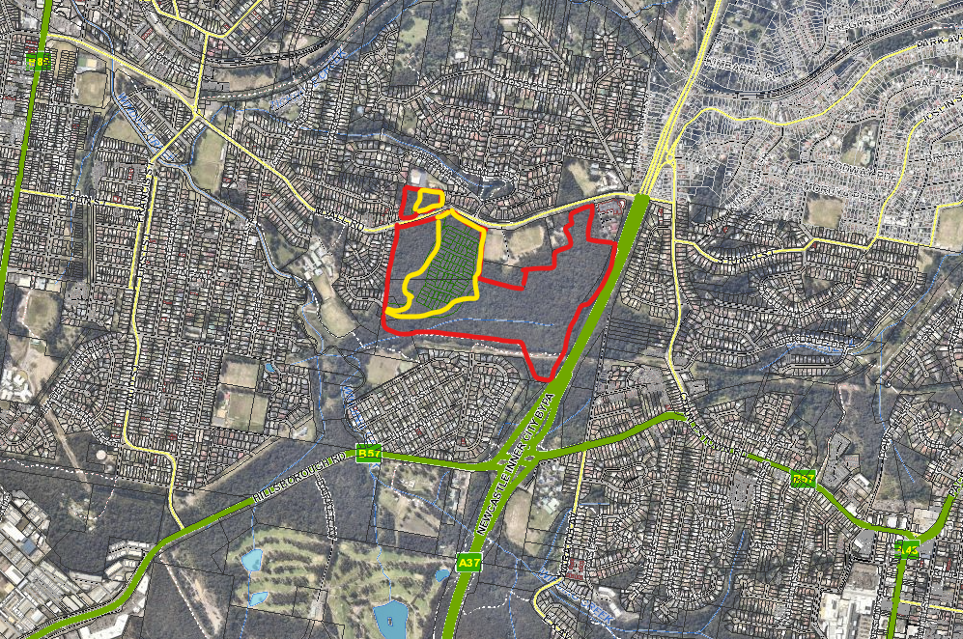
Cardiff Rail Station
Public School
High School
Northern and Southern development precincts
Site
Figure 1 Site location

Proposal
Consent is sought for a residential subdivision that will create 66 standard residential lots, three larger lots for future medium density housing and three lots for conservation purposes.
The development is divided into two precincts; a northern precinct and a southern precinct. The majority of the development is located the southern side of Myall Road, with one larger lot and one conservation lot located on the northern side of Myall Road.
Access to the southern development precinct is via an upgraded intersection to be constructed at the current Gymea Drive / Myall Road intersection. Secondary access is provided by a connection to existing residential streets west of the site to Gillian Crescent.
The southern development precinct proposes 66 residential lots, with associated roads, drainage, regrading works and landscaping. Two development lots adjoining Myall Road (Lots 67 and 68) are proposed to be subdivided under this application, however it is expected further development of these lots will occur under separate development applications.
No works are proposed for the northern precinct as part of this application. This application proposed to subdivide the northern development precinct to create a future development lot (Lot 69) and a biodiversity offset lot (Lot 70).

Northern Precinct
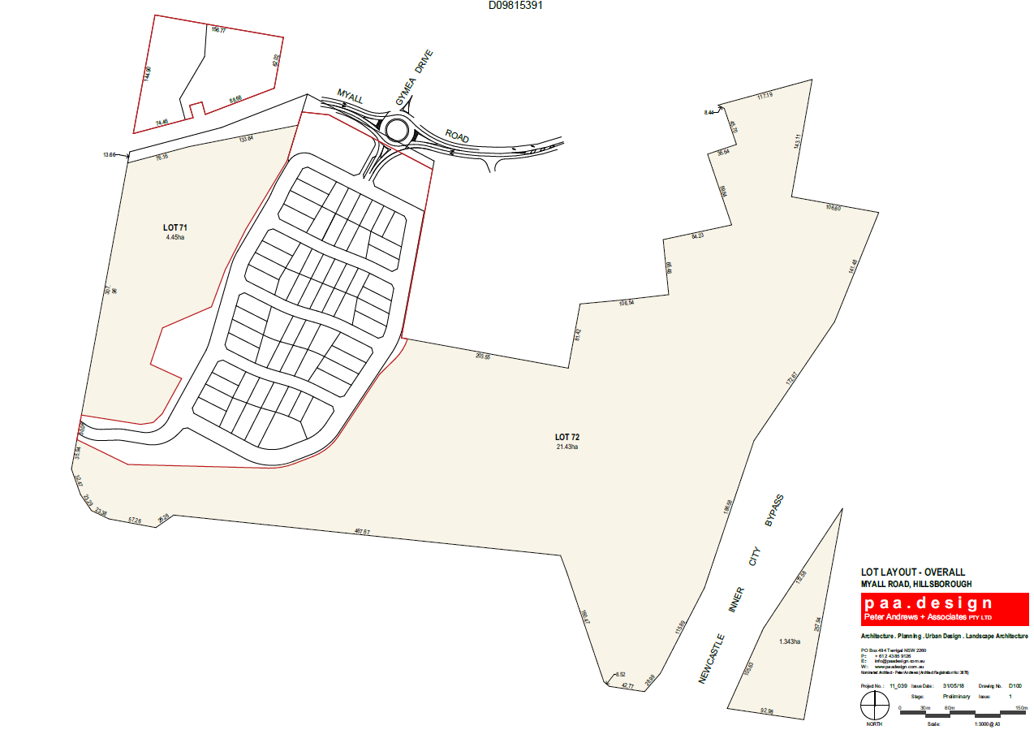
Conservation Lots
Southern Precinct
Figure 2 Development precincts and proposed lot layout

5A Test of Significant effect on threatened species, populations or ecological communities, or their habitats

Consideration must be given to whether a development will have a significant effect on threatened species, populations or ecological communities, or their habitats against the provisions of the clause and also the assessment guidelines contained in the Threatened Species Conservation Act 1995 (TSC).
The application proposes to:
- impact 10.7ha of vegetation including known habitat for threatened Tetratheca juncea, squirrel glider and large forest owl.
The areas to be cleared have been selected to minimise the impact on the highest value bushland and threatened flora.
- offset impacts by establishing the remaining 28.1ha of the site as a Biodiversity Stewardship Agreement (BSA) site with the Biodiversity Conservation Trust. This area will comprise a total of three lots.
The offset site provides known habitat for the above species and includes requirement for a Vegetation Management Plan (VMP) and management funding.
Conditions are also recommended requiring the voluntarily retirement of all biodiversity credits generated from the established BSA site to the BCT, and the registration on title of a covenant burdening the conservation lots subject to the BSA site offset.

Council have received advice a stewardship site or conservation agreement can, if it so chooses to do so, be established under Part 6 of the Biodiversity Conservation Act given the legislation is now operational.
- mitigate and manage development and edge impacts by incorporating a perimeter road, post and cable boundary fence, turfing batters with native grasses and implementation of a Construction Management Plan.

An assessment of the development against provisions of the Act, including TSC guidelines has been included in the Biodiversity Assessment Report and Addendum Biodiversity Assessment Report. Clearing for the access to the site, as a result of the construction of a roundabout, was included and assessed these assessments, with offsets accounted for.

The development is considered to not present a significant impact on threatened species, populations or ecological communities, or their habitat.

A Species Impact Statement (SIS) has not been requested.

Integrated Development Assessment

Coal Mine Subsidence Compensation Act 2017

Section 22 Approvals for development within mine subsidence districts
The application was lodged as integrated development and was referred to the Mine Subsidence Board in 2013; approval was received in May 2014. This approval lapsed after two years.
The application was referred to Subsidence Advisory NSW (SA NSW) in May 2018. SA NSW provided General Terms of Approval (GTAs) dated 30 July 2018. SA NSW confirmed the portion of the site to be developed is suitable for residential use. Any potholes or sinkholes located on the eastern part of the site (within the biodiversity offset land) are required to be remediated to SA NSW’s satisfaction.
GTAs are referenced in the recommended conditions of consent.
Rural Fires Act 1997
Section 100B Bush fire safety authorities
The application was lodged as integrated development and was referred to the NSW Rural Fire Service (RFS) on four separate occasions. On each occasion the RFS provided GTAs that superseded the previously issued GTAs.
The most recent GTAs were issued on 22 October 2020 and are referenced in the recommended conditions of consent.
The GTAs require the development to comply with latest version of the Planning for Bushfire Protection 2019 (PfBP). The subdivision was designed is accordance with the previous version of the PfBP and generally complies through provision of a perimeter road, two alternate accesses, and the ability to provide compliant asset protection zones whilst still retaining suitable building areas within each of the residential lots.
However some changes are required to the design of the subdivision to comply with current PfBP. This includes provision of ‘clear’ carriageway widths that are to be available at all times which requires an eight metre carriageway perimeter road and seven metre wide internal road.
The development proposes an eight metre wide perimeter road and seven metre wide non perimeter roads, however anticipates on-street parking. Therefore adjustments are required to the roadway to ensure a clear carriageway is maintained.
The proposed perimeter road reserves are generous and Council is satisfied parking bays can be easily accommodated within the existing reserve and not require additional clearing. These adjustments can be incorporated during the detail civil design stage.
Non-perimeter roads will need to be widened by one metre to achieve an eight metre carriageway (with a corresponding widening of the associated road reserve) and incorporate no parking restrictions on one side of the road. The lots adjacent to the non-perimeter roads have sufficient depth to accommodate this adjustment, whilst still maintaining sufficient building envelopes.
The above adjustments are incorporated into recommended conditions of consent.
Water Management Act 2000
Section 91 Activity approvals
The application was lodged as integrated development and was referred to the Department of Primary Industries – Office of Water; GTAs were issued 23 October 2013. The GTAs require any works within proximity of the watercourse to obtain a Controlled Activity Approval prior to the issue of a Subdivision Works Certificate.
The Natural Resources Access Regulator (NRAR) confirmed in October 2020 that a re-referral was not necessary and the original GTAs remain current. The GTAs are referenced in the recommended conditions of consent.

Section 4.15: Potential matters for consideration
Applicable State, Regional and Local Environmental Planning Instruments and Policies are detailed hereunder. Where not explicitly detailed, it is considered those instruments or policies are not relevant to the proposal.

Section 4.15 (1) (a) (i) the provisions of any EPI’s
State Environmental Planning Policy No. 19 – Bushland in Urban Areas
The development adjoins land zoned 6(a) Open Space (Public Recreation) and 6(1) Open Space, and is located on land zoned 6(c) Open Space (Local Reservation). Refer to Figure 3.
The development footprint includes land located within the 6(c) Open Space (Local Reservation) zone, and proposes to clear vegetation within the 6(c) Open Space. The other areas of 6(c) Open Space zoned land to the south and south east of the site are contained within the land proposed for conservation and as such will not be cleared.
Clause 6(4) applies to land zoned for bushland or public open space and states development consent shall not be granted unless the consent authority is satisfied of the following:
- an assessment of the need to protect and preserve the bushland having regard to the aims of the policy.
The development footprint will result in the removal of approximately 1.6ha of bushland zoned for open space.
Overall the application proposes to protect and preserve 27 hectares of bushland within the biodiversity offset lots, which is considered to appropriate balance the removal of the bushland zoned for open space. This outcome is considered to be consistent with the aims of the policy.
- the disturbance of the bushland is essential for a purpose in the public interest and no reasonable alternative is available to the disturbance of that bushland

The development footprint has been located to achieve a balanced outcome to maximise retention whilst addressing other constraints of the site.
Other alternatives have not been explored, however these would likely impact upon the overall biodiversity conservation lots and provide a poorer outcome. Council is satisfied that no reasonable alternative is available.
- the amount of bushland proposed to be disturbed is as little as possible and, where bushland is disturbed to allow construction work to be carried out, the bushland will be reinstated upon completion of that work as far as is possible.
It is considered the amount of bushland zoned open space that is to be disturbed, is appropriate given the balanced outcomes achieved across the site.
The development adjoins land zoned 6(a) Open Space (Public Recreation) and 6(1) Open Space. The land zoned 6(a) is a public reserve used primarily for sporting fields. A portion of bushland is contained within the reserve along the southern boundary of the fields. Clause 9(2) applies to land adjoining land zoned for bushland or public open space and states development consent shall not be granted unless the consent authority has taken in to account the following:
- the need to retain bushland
- the effect of the proposed development on bushland or public open space, in particular, erosion of soils, siltation of streams and waterways and spread of weeds and exotic plants within the bushland
The application proposes a road reserve interface to bushland along part of the eastern boundary of the residential development, which incorporates a generous nature strip adjacent to the bushland.
No works are proposed along the southern boundary of the bushland.
Council is satisfied the bushland will not be impacted by civil and landscaping works. A construction management plan has been recommended, which incorporates mitigation measures for adjoining lands.
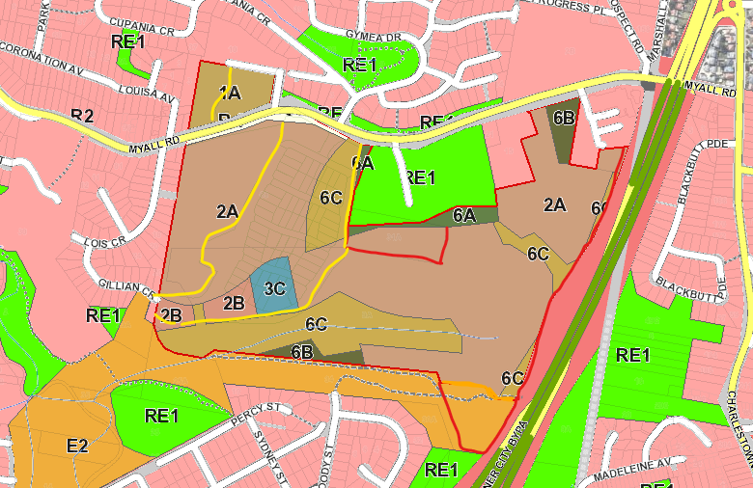
Figure 3 Site zoning
State Environmental Planning Policy No 44 – Koala Habitat Protection
The land has an area of more than one hectare, and is subject to the provisions of the SEPP.
An assessment of the land against the SEPP has been included in the Biodiversity Assessment Report, and concluded the site is not core koala habitat. Council’s Flora and Fauna Planner has assessed the report and supports the recommendations.
In accordance with clause 10, consideration to the guidelines under Circular B35 have been taken in to consideration.
In accordance with the SEPP, consent may be granted to the development application.

State Environmental Planning Policy No. 55 – Remediation of Land
Under clause 7 of the SEPP states a consent authority must not consent to the carrying out of any development on land unless:
- it has considered whether the land is contaminated, and
- if the land is contaminated, it is satisfied the land is suitable in its contaminated state (or will be suitable after remediation) for the purpose for which the development is proposed to be carried out, and
- if the land requires remediation to be made suitable for the purpose for which the development is proposed to be carried out, it is satisfied that the land will be remediated before the land is used for that purpose.
Contamination assessments were undertaken in 2012 and October 2020. The assessments identified the site contains several localised areas of potential contamination from opportunistic illegal dumping of building materials, fill and car bodies.
The reports confirm the potential contamination is capable of being remediated through off-site disposal to a licensed landfill after undertaking a waste classification.
To ensure remediation is undertaken a detailed contamination assessment and Remediation Action Plan will be condition to be provided prior to the issue of a Subdivision Works Certificate. Validation that the site has been remediated and is suitable for its intended use will be conditioned to be provided prior to the issue of a Subdivision Certificate.

State Environmental Planning Policy (State and Regional Development) 2011
The proposal is identified as regionally significant development under Part 4 Regionally significant development of the SEPP and Schedule 4A of the EPA Act due to the capital investment value exceeding $5 million for Crown development.
The development has a value of $5,115,000 and the Hunter and Central Coast Regional Planning Panel (RPP) will be the consent authority for the application.

State Environmental Planning Policy (Infrastructure) 2007

18 Additional uses of certain State land permitted
Clause 18(3) of the SEPP enables development of State land for purposes permitted on adjoining lands if there is a valid SCC applying to the development, and the land was State land at the time of the issue of the SCC.
The land is owned by the State of NSW and currently is being administered by the New South Wales Land and Housing Corporation. The land was State land at the time the SCC was issued.
A SCC has been issued for the development on 7 September 2012, and again on 6 October 2017. The current SCC is due to expire on 6 October 2022 (five years from the date of issue). The SCC certifies the development of the site for:
- 70-80 dwellings in southern precinct, and
- 20-25 dwellings in northern precinct.
and is compatible with the surrounding land uses and is not likely to have an adverse effect of the environment and does not cause any unacceptable environmental risks to the land.
The application proposes development that is consistent with the SCC, as follows:
- single future residential development lot in the northern precinct which enables 20-25 dwellings;
- 66 residential lots and two future development lots in the southern precinct.
The future development lots in the southern precinct will be limited to a maximum yield of 14 dwellings to remain consistent with the SCC.
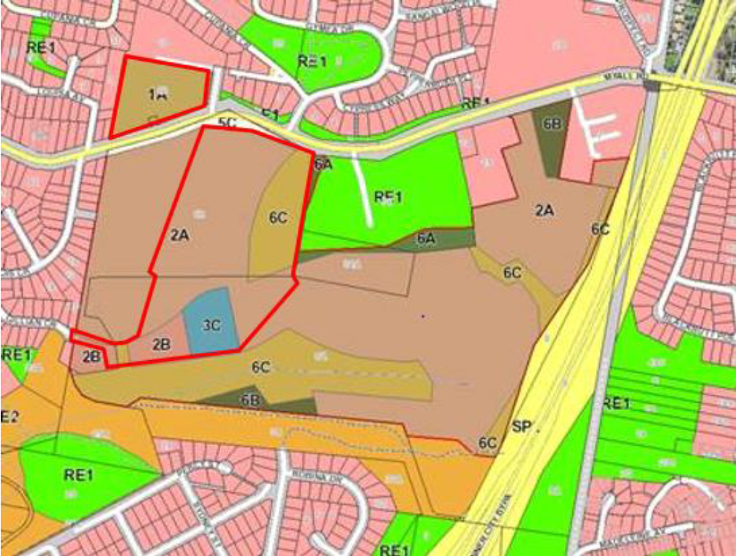
Southern Precinct
Northern Precinct
Figure 4 Site compatibility certificate lands
Subdivision 2 Development likely to affect an electricity transmission or distribution network / 45 Determination of development applications—other development
In accordance with clause 45(2) of the SEPP, the application was referred to Ausgrid for comment.
The development does not impact the Ausgrid easement at the site, and Ausgrid raised no objection to the development.
Conditions of consent are recommended to require the developer to contact Ausgrid and adhere to any requirements for installation of electrical infrastructure.

Lake Macquarie Local Environmental Plan 2004
Clause 2 Land to which plan applies
Clause 2 specifies LMLEP 2004 does not apply to land shown as “deferred” on the map.
A majority of the site is a deferred matter under LMLEP 2004, and the LMLEP 1984 applies for these portions.
Land not mapped as ‘deferred’ under LMLEP 2004 is zoned under LMLEP 2004 as follows:
- 6(1) Open Space
- 7(2) Conservation (Secondary) Zone
Refer to Figure 5 which demonstrates deferred lands in solid white, and outline of site in purple.
Consideration of relevant LMLEP 2004 clauses in relation to the 6(1) and 7(2) zoned lands is detailed below.
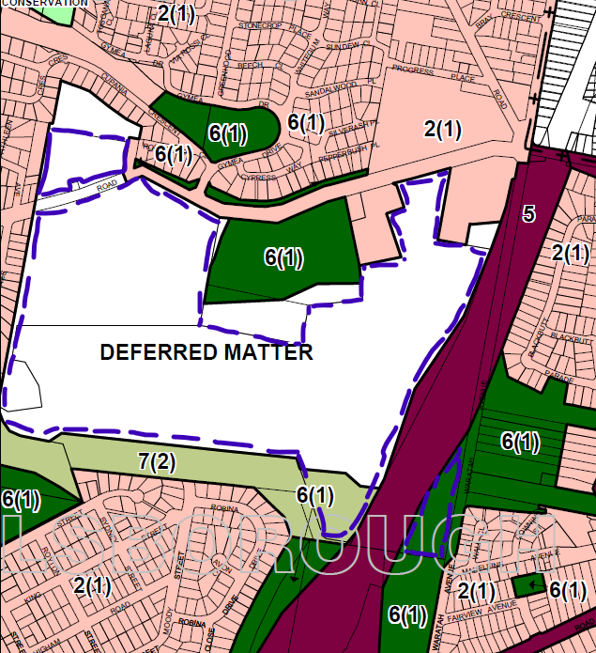
Figure 5 Deferred lands and LMLEP 2004 zoning
Clause 15 General controls for land within zones
The application includes land zoned 6(1) Open Space and 7(2) Conservation (Secondary).
The portions of 6(1) and 7(2) zoned lands will be amalgamated into the biodiversity offset lot. The development is consistent with these zones by facilitating the preservation and ongoing management and rehabilitation of lands with conservation value.
The portions of 7(2) zoned land will be amalgamated into the biodiversity offset lot. The development is consistent with the 7(2) Conservation (Secondary) zone by facilitating the preservation of the environmental qualities of the land.
Part 4 Special provisions applying to all land
Clause 16 Development consent – matters for consideration
Consent must not be granted for development unless the consent authority has:
- had regard to the vision, values and aims of Lifestyle 2020
- is satisfied the development is consistent with the zone objectives.
The development generally satisfies the aims of the Lifestyle 2020 Strategy. The development provides a compact outcome that will enable a variety of housing types, and will conserve lands with conservation values.
Refer to clause 15 LMLEP 2004 for consideration of zone objectives.
Clause 21 Development the subject of SEPP 1 application
The application proposes to vary the minimum lot size for 7(2) zoned lands under clause 24 and Schedule 2. Clause 21 enable variations to development standards including minimum lot size.
A SEPP 1 objection to the development standard has been submitted to support the variation to the minimum lot size. Note, in accordance with clause 7 of State Environmental Planning Policy (Concurrences and Consents) 2018, SEPP 1 continues to apply to an application made but not finally determined before its repeal. SEPP 1 was repealed in February 2020.
The application proposes to amalgamate 7(2) zoned lands into the biodiversity offset lot. The portion of the site zoned 7(2) is approximately 1.3ha, and will be amalgamated with other lands to have an area of 21.43ha. The minimum subdivision lot size for 7(2) zoned land is 40ha and a variation of 38.7 hectares (96%) is proposed.
Development consent must not be granted for development that contravenes a development standard unless the consent authority has considered a written objection from the applicant that seeks to justify the contravention of the development standard by demonstrating,
- that compliance with the development standard is unreasonable or unnecessary in the circumstances of the case, and
- specifying the grounds of the objection.
The applicant’s written objection has argued the objectives of the subdivision standards would be defeated or thwarted if compliance was required and therefore compliance is unreasonable and unnecessary. In particular, the written variation argues:
- The proposed development footprint has been developed to create conservation areas, together with appropriate biodiversity offsets, within both the northern and southern precincts, to ensure the proposed subdivision provides a good environmental outcome for the native flora and fauna located within the confines of the site.
- The proposed variation is considered to be consistent with the objectives of the 7(2) zone, in that it will protect, conserve and enhance land that is environmentally important and will result in rehabilitation and conservation of environmentally important land.
- The conservation area including the subject 7(2) lands will be retained, enhanced and rehabilitated to both protect existing native vegetation and encourage re-vegetation.
- Strict compliance with the minimum lot size control would thwart achievement of the zone and LEP objectives, and is considered unnecessary in this instance, particularly as the objectives of the control are achieved despite the non-compliances.
- The development is consistent with clause 4.1E of the LMLEP 2014.
Council consider the applicant’s SEPP 1 objection has appropriately articulated compliance with the development standard is unreasonable or unnecessary in the circumstances of the case, and the objection is well founded.
In consideration of the SEPP 1 objection, Council has considered the development will be in the public interest because;
- it is consistent with the objectives of the subdivision minimum lot standards; and
- is consistent with the objectives of the 7(2) Conservation (Secondary) zone.
Consideration also needs to be given to whether the variation raises any matter of significance for state or regional environmental planning, and the public benefit of maintaining the standard.
The objectives of the clause 24 are not explicitly stated. In the absence of clear objectives, it is assumed the minimum lot size is to ensure the objectives of the zoning of the land can be maintained. The development is considered to achieve this despite the variation to the development standard, as the conservation land is maintained in its current state. No adverse impacts are experienced to this portion of land, and the land is in fact benefited from amalgamation with surrounding lands to comprise a biodiversity offset.
The development is considered to be consistent with the objectives of the zone as the variation will enable the protected, conservation and enhancement of the land.
In this regard, the development is consistent with the subdivision standards and zone objectives, and is in the public interest.
The variation does not raise any matters of state or regional significance. Further, there is no public benefit in maintaining strict compliance with the standard given no unreasonable impacts result from the variation.
Compliance with the development standard is considered to be unreasonable and unnecessary and compliance would hinder the objects of the Act.
As the consent authority for the development application, the RPP have delegation to determine the SEPP 1 objection.
Clause 24 Subdivision
Land in any zone may be subdivided if the consent authority is satisfied:
- the resulting lots will conform to the requirements in Schedule 2 (Subdivision standards) applicable to subdivision in that zone,
- the resulting lots can be developed in accordance with this plan.
The applicable minimum lot sizes are as follows:
- 6(1) Open Space – No minimum lot size
- 7(2) Conservation (Secondary) Zone – 40ha
The 7(2) portion of the site is approximately 1.3ha, and does not comply with the minimum lot size. This portion of the site will be amalgamated in proposed Lot 72 (biodiversity offset lot) which has an area of 21.43ha.
A SEPP 1 objection to the development standard has been submitted to support the variation to the minimum 7(2) lot size. The SEPP 1 objection has been reviewed and is supported by Council. Refer to consideration under clause 21 LMLEP 2004.
Clause 30 Control of pollution
Consent must not be granted to development unless the consent authority is satisfied all reasonable and practicable control measures will be implemented to minimise pollution likely to arise from carrying out that development.
No works associated with the subdivision are proposed on the 6(1) or 7(2) zoned lands. However pothole remediation has been identified in the eastern potion of the site adjacent to the Newcastle Inner City Bypass and it is likely some potholes will be required to be filled in.
Recommended conditions will ensure these works implement appropriate pollution control measures.
Clause 31 Erosion and sediment control
Consent must not be granted to development to which this clause applies unless the consent authority is satisfied all reasonable and practicable control measures will be carried out to prevent or minimise the effects of erosion and sediment, and an appropriate erosion and sediment control plan has been submitted.
No works associated with the subdivision are proposed on the 6(1) or 7(2) zoned lands. However pothole remediation has been identified in the eastern portion of the site adjacent to the Newcastle Inner City Bypass and it is likely some potholes will be required to be filled in.
Recommended conditions will ensure these works implement appropriate erosion and sediment control measures.
Clause 32 Flood prone land
Consent must not be granted unless the consent authority is satisfied:
- the development is consistent with a flood management plan applying to the site
- be satisfied the development is consistent with the flood hazard and levels of risks.
Part of the site is subject to flooding from local creeks. Specifically, flooding occurs within the Winding Creek tributary that flows from east to west and is located south of the development footprint in the southern precinct
No works or lots associated with the subdivision are proposed on the 6(1) or 7(2) zoned lands and as such there are no flooding issues impacting these lands.
Clause 33 Bushfire considerations
The land is identified as bushfire prone. No works or lots associated with the subdivision are proposed on the 6(1) or 7(2) zoned lands and as such there are no bushfire issues impacting these lands.
Clause 50 Development affecting places or sites of known or potential Aboriginal heritage significance
Consent must not be granted for development that is likely to have an impact on a place (or potential place) of Aboriginal heritage significance unless the consent authority has considered a heritage impact statement has been submitted.
An Aboriginal Due Diligence Report has been submitted with the application, and the report did not identify any Aboriginal sites or relics.
The application was referred to the local Aboriginal Land Council, and no response was received.
The development will therefore not have impacts to the City’s heritage.

Lake Macquarie Local Environmental Plan 1984
A majority of the site is a deferred matter under LMLEP 2004, and the Lake Macquarie Local Environmental Plan 1984 (LMLEP 1984) applies for these portions.
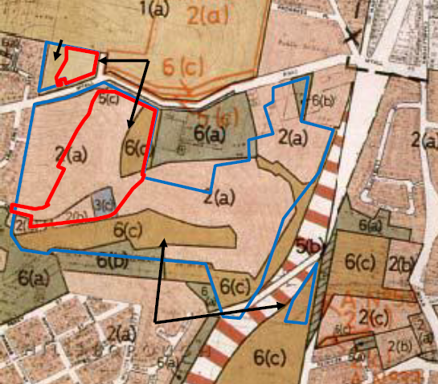
Figure 6 LMLEP 1984 Zoning Map with development precincts
Clause 11 Subdivision of land
The clause identifies that a person shall not subdivide land without the consent of the Council. Accordingly the application has been lodged seeking consent for the subdivision of land.
Clause 12 Subdivision of land in Zone 1(a), 1(b), 1(c), 7(a), 7(b) or 7(d)
The clause identifies land zoned 1(a) shall not be subdivided unless the resultant lot is not less than 40ha.
The application proposes subdivision of land zoned 1(a) which has an area of approximately 1.65ha and does not comply with the minimum lot size.
As an alternate avenue to varying the minimum lot size, the applicant obtained a Site Compatibility Certificate (SCC). For discussion, refer to State Environmental Planning Policy (Infrastructure) 2007 / 18 Additional uses of certain State land permitted.
Clause 17 Provision of water supply, sewerage and drainage
The clause states consent shall not be granted unless and satisfactory arrangements have been made for the provision of water, sewage and stormwater infrastructure.
The application was supported by an infrastructure assessment. This assessment indicates all utility infrastructure is able to be made available to service the development. Servicing will be from Myall Road, except for sewer which is to connect to the existing system in Gillian Crescent. No significant clearing of vegetation is required to enable this servicing.
Conditions are recommended to restrict clearing of vegetation within the proposed biodiversity offset lots for the provision of services.
Clause 19 Acquisition and development of land
This clause identifies the owner of land zoned 5(c) Special Uses (road reservation) and 6(c) (open space) may require the Council to acquire the land.
The application proposes to dedicate the 5(c) zoned areas along Myall Road as road and are shown on the plan of subdivision as landscape buffer. Conditions are recommended to require the dedication of the land zoned 5(c) for road widening.
The land zoned 6(c) forms part of the land to be developed as residential lots and is captured by the SCC.
For those 6(c) zoned lands not included in the SCC, clause 19(9) states consent shall not be granted unless consideration has been given to the following:
- need for the proposed development on the land
- impact of the proposed development on existing and likely future use of the land
- need to retain the land for its existing or likely future use
These areas of 6(c) are located within the biodiversity offset lands. No works are proposed within these lands, and the lands will be protected. This is considered appropriate.
Clause 22A Development of flood liable land
Part of the site is subject to flooding from local creeks. Specifically, flooding occurs within the Winding Creek tributary that flows from east to west and is located south of the development footprint in the southern precinct
A flood study has been submitted that confirms all areas to be developed for residential lots are clear of flooding.
Clause 25 Development within Zone 6(a), 6(c) or 6(e)
This clause relates to land that is owned, controlled or proposed to be owned by the Council. For those 6(c) zoned lands not included in the SCC, clause 25 states consent shall not be granted unless consideration has been given to the following:
- need for the proposed development on the land
- impact of the proposed development on existing and likely future use of the land
- need to retain the land for its existing or likely future use
These areas of 6(c) are located within the biodiversity offset lands. No works are proposed within these lands, and the lands will be protected. Council does not intend to acquire the 6(c) lands within the development site and the inclusion of the land within the conservation lots is supported.
Clause 34 Protection of heritage items and clause 35 Development
The site is not in a heritage conservation area and does not contain an identified heritage item. Nor are items of significance or potential archaeological sites located on sites in the vicinity.
An Aboriginal Due Diligence Report has been submitted with the application, and the report did not identify any Aboriginal sites or relics. The development will therefore not have impacts to the City’s heritage.

Section 4.15 (1) (a) (ii) the provisions of any draft EPI
The following draft EPI’s have been exhibited since the lodgement of the application.
EPI | Savings provisions | Discussion
State Environmental Planning Policy No. 1 – Development Standards | Yes – cl.7 State Environmental Planning Policy (Concurrences and Consents) 2018 | SEPP 1 has been repealed, and replaced with the provisions of clause 4.6 of the Standard Instrument.  Clause 4.6 contains different content, however maintains the same intent for consideration of variations to development standards.
State Environmental Planning Policy No. 19 – Bushland in Urban Areas | Nil | SEPP 19 remains in force.  Clause 6(4) and 9(2) are materially the same.
State Environmental Planning Policy No. 55 – Remediation of Land | Nil | SEPP 55 remains in force and is materially the same.
State Environmental Planning Policy (Infrastructure) 2007 | Yes - cl.11 ISEPP  SCC valid until 6 October 2022. | ISEPP remains in force.  Clause 18 and 19 have been rewritten but remain materially the same.
State Environmental Planning Policy (State and Regional Development) 2011 | Nil applicable to the development | The SEPP remains in force.  Clause 20 has been rewritten and enacts the provision of Schedule 7 which now sets out regionally significant development (moved over from the Act).  The SEPP provisions remain materially the same.
State Environmental Planning Policy (Koala Habitat Protection) 2019 commenced on 20 December 2019, and repealed SEPP 44. | The new SEPP repeals the former State Environmental Planning Policy No. 44 - Koala Habitat Protection  Clause 15 of the new SEPP contains savings provisions. | The new Koala SEPP maintains the same aim to protect koala habitat.  The new SEPP provisions remain materially the same as follows:  - applies to land more than 1ha  - requires consideration to guidelines and provisions to assess potential and core koala habitat and impact of development.
Lake Macquarie Local Environmental Plan 2014 (LMLEP 2014).  LMLEP 2014 commenced in September 2014 following the lodgement of the application | Yes – cl1.8A LMLEP 2014 | Clause 2.3 Zone objectives and Land Use Table  Under LMLEP 2014 the land is zoned as follows:  - RE1 Public Recreation (no minimum lot size)  - E2 – Environmental Conservation (40ha minimum lot size)  These portions of land reflect those zoned 6(1) and 7(2) under LMLEP 2004 and maintain the same objectives.
Clause 2.6 Subdivision – consent requirements
Subdivision of land is permitted with consent under clause 2.6, in accordance with the minimum lot sizes specified on the Lot Size Map, and the zone objectives.
The RE1 and E2 portions of the site will be amalgamated in proposed Lot 72 (the biodiversity offset lot). This would have required a clause 4.6 variation to be submitted, as has been for the SEPP 1 objection to the LMLEP 2004 minimum lot size.
Clause 4.1 Minimum subdivision lot size
The clause allows lots to be approved that are less than the minimum lot size shown on the lot size map if the consent authority is satisfied that
- the subdivision will facilitate the long-term biodiversity conservation management of the lot, and
- suitable arrangements have been, or will be, made for the long-term protection, conservation and management of the lot, and
- the subdivision will not create the opportunity for additional dwellings on any of the lots
- the subdivision will not require the clearing of any native vegetation other than native vegetation required to be removed for the long-term protection, conservation and management of the lot.
The application proposes to offset the RE1 and E2 zoned lands for the purposes of conservation, which will have arrangements for ongoing protection and management. No vegetation clearing is required within these lands.
The application will not create the opportunity for additional dwellings.
Clause 7.3 Flood planning
Consent must not be granted unless the consent authority is satisfied:
- is compatible with the flood hazard of the land, and
- will not significantly adversely affect flood behaviour resulting in detrimental increases in the potential flood affectation of other development or properties, and
- incorporates appropriate measures to manage risk to life from flood, and
- will not significantly adversely affect the environment or cause avoidable erosion, siltation, destruction of riparian vegetation or a reduction in the stability of river banks or watercourses, and
- is not likely to result in unsustainable social and economic costs to the community as a consequence of flooding.
No development is proposed on these lands and as such there are no flooding issues impacting these lands.
Biodiversity Conservation Act 2016 (BC)  Commenced on 23 November 2016 with the biodiversity offset scheme commencing within the LMCC LGA on the November 28 2018 | Yes  Schedule 9 of the BC Act and clause 28 of the Biodiversity Conservation (Savings and Transitional) Regulation 2017 contains savings provisions that enable the former planning provisions to continue to apply | The EPA act remains in force.  Clause 1.7 (ex. 5A) has been rewritten and enacts the provision of BC Act.  The (new) BC Act:  - requires applications to avoid and minimise significant habitat and complete a test of significance that is essentially the same as that which has been applied to the site under the former planning provisions;  - identifies land of Biodiversity Value (BV).  Mapped BV areas do not occur on the Myall Road site;  - introduces a Biodiversity Offsetting Scheme (BOS).  The application would have triggered clearing thresholds under the BC Act if the BOS was applied.  Regardless, the application proposes offsets.

Section 4.15 (1) (a) (iii) DCP’s

Lake Macquarie Development Control Plan 2014
The Lake Macquarie Development Control Plan 2014 (LMDCP 2014) was adopted by Council on 11 June 2013.

Part 8: Subdivision Development

2.2 Site Analysis
Adequate site analysis documentation has been submitted.

2.3 Scenic values
The site is located within an area of moderate to low scenic quality as identified by Council’s Scenic Management Guidelines.
A Visual Impact Assessment (VIA) has been submitted with the application.
The VIA recommends tree planting throughout the development and along the Myall Road frontage to ameliorate impacts. Landscaping plans have been submitted demonstrating suitable outcomes.
The application proposes vegetation removal within the development footprint. Despite this, appropriate visual outcomes are maintained to surrounding viewpoints given significant areas of vegetation will be retained to the west, south and east of the development footprint. Future development of these lands for residential development will not be visually prominent from these aspects.
The southern precinct has direct frontage to Myall Road and the land (and future built form) on the residue residential lots adjacent to Myall Road will be visible from vehicles travelling along the roadway, and from dwellings on the northern side of Myall Road. Future development of these lands for residential development will be consistent with surrounding residential development and compliment the local context.
2.4 Geotechnical
A Slope Stability Report has been submitted with the application. The report identifies the risk of slope instability ranges from very low to medium across the development footprint. Medium risk areas can be reduced to low with suitable construction methods in the subdivision.
Conditions are recommended to require construction plans be certified by a Geotechnical Engineer to ensure a low risk is achieved on the resultant lots.
2.8 Water Cycle Management
A Water Cycle Management Plan has been submitted with the application.
The development proposes sediment basins during construction, which will be converted into three detention basins containing biofiltration filters after construction is complete. Gross pollutant traps (GPTs) will also be provided to remove rubbish and sediment from stormwater before it enters the basins.
The stormwater modelling demonstrates the development will not increase stormwater flows downstream of the development for all storms up to the 100 year recurrence interval. The GPTs and biofiltration filters will ensure stormwater nutrient loadings meet Council’s guidelines.
2.11 Natural Water Systems
The site is located in the Winding Creek catchment and contains a small natural watercourse located in proximity to the southern boundary. The creek will be retained within the biodiversity offset lot, with riparian buffers included. The stormwater quantity and quality controls proposed will mitigate any impacts on the creek and the associated riparian vegetation.
2.18 Social Impact
A Social Impact Assessment (SIA) was submitted with the application. The report identifies the development is consistent with the character of the locality and there are adequate community facilities and services in the area that are accessible to and will support the development.
3. Subdivision Design
The DCP sets out minimum lot dimensions and areas for subdivisions in the different land use zones. Given the variety of land use zones within separate LEPs across the site, the following considers lot outcomes against equivalent land use zones under LMDCP 2014.
3.6 Lot Sizes and Dimensions – R2 Low Density Residential Zone
Future low density residential lots include Lots 1 - 66 and range from 492m² to 1653m² and comprise standard allotments, corner allotments and irregular shaped lots.
Proposed low density residential lots are considered to provide appropriate areas and shapes to enable orderly development for future dwellings.
3.7 Lot Sizes and Dimensions – R3 Medium Density Residential Zone
Future medium density residential lots include Lots 67 - 69 and range from 2963m² to 8800² and provides sufficient areas and shapes to enable orderly development for future medium density residential development.
3.18 Subdivision Layout
The subdivision layout is a modified grid pattern, including perimeter road to meet bushfire management requirements.
All residential lots have frontage to a public road and are generally rectangular in shape.
Residential lots have appropriate orientation and future residential development can achieve good solar access.
The road pattern provides good connectivity within the development. Efficient access is provided within the site to a collector road (Myall Road) through the construction of the proposed roundabout on Myall Road. An integrated footpath and shared pathway network is also incorporated into the design.
3.20 Movement System
The subdivision incorporates an efficient road and pathway pattern that provides good connectivity throughout the development for vehicles and pedestrians.
3.21 Road Design
Intersection
Access to the southern precinct will be via a proposed roundabout on Myall Road. This is yet to be constructed, however has been identified in Council’s Glendale Contributions Plan with design and approval by Council expected to be complete by June 2021.
The development will be subject to 7.11 development contributions which will contribute to the funding of this intersection. Conditions are recommended to restrict the release of any lots until the intersection is operational.
The land available for the construction of the intersection is relatively flat and significant earthworks is not required to facilitate the works. Some clearing of vegetation will be required however this clearing has been assessed in the ecology reports submitted with the application.
The roundabout will also benefit existing residents on the northern side of Myall Road exiting Gymea Drive.
Access to the northern precinct is not included in this application. Access to this land currently exists from Reserved Road, and it is expected this access will be suitable for the future development of the northern precinct. This will be considered during the assessment of the future development application/s for this land.
Internal road network
The application proposes an eight metre wide perimeter road and seven metre wide internal road. As previously discussed, internal roads will be widened to eight metres, with parking bays to perimeter roads, to satisfy bushfire requirements.
Council is satisfied these adjustments can be achieved within the development footprint and not require any additional clearing. Details of these adjustments can be incorporated into the final detailed engineering design.
The road grades range up to 16%, which are consistent with Council’s requirements.
Alternate secondary access is proposed via Gillian Crescent to the south-west. It is not expected future residents of the development will utilise this access often given the roundabout to Myall Road is more direct and superior, and any impacts have been considered acceptable.
3.22 Pedestrian and Cycle Network
The application includes footpath for the full perimeter of the southern precinct, which will connect to the new intersection at Myall Road, and provide further connection to the existing shared pathway system on the northern side of Myall Road.
3.23 Public Transport
The development will have direct access to Myall Road. Myall Road is well serviced by public buses with four separate routes (262,763, 858 and 863), with existing bus stops located in close proximity to the site. Cardiff Train Station is also only 1.7 km from the site.
3.25 Open Space and Recreation
The development will be subject to 7.11 development contributions which will contribute to the upgrade of open space and recreation facilities within the contribution catchment.
3.26 Safety and Security
The location and design of the subdivision raises no significant safety or security concerns.
3.27 Site Benching
The application proposes to bench approximately two-thirds of the lots. Retaining walls up to 1.2 metres high are indicated on the preliminary civil design plans.
This outcome is considered appropriate and is consistent with Council’s DCP and endorsed development practices in the City.
3.28 Street Trees and Streetscape Improvements
Preliminary landscaping plans have been submitted which includes street trees to both sides of all internal roads. Landscaping of stormwater management facilities is also proposed.
Conditions are recommended to require final landscaping plans be submitted for assessment with the Subdivision Works Certificate.
4 Subdivision Construction
Conditions of consent are recommended to address construction impacts including erosion and sediment control, air quality, noise and vibration impacts, and waste management. A construction management plan is also recommended.
Council is satisfied impacts from the construction of the development can be adequately managed.

Section 4.15 (1) (a) (iv) any matters prescribed by the regulations
Nil

Section 4.15 (1) (b) the likely impacts of the development

The likely impacts of the development contained in this part of the Act have been detailed throughout the assessment report.
It is considered that impacts will be satisfactory mitigated, or are not significant.

Section 4.15 (1) (c) the suitability of the site for development

Does the proposal fit the locality?
The development is considered to fit the locality. The development is consistent with the surrounding residential uses and the existing character of the area. The development preserves significant areas of native bushland and poses no significant adverse impacts.

Are the site attributes conducive to development?
As demonstrated in this report, the site is conducive to the development proposed.

Section 4.15 (1) (d) any submissions made in accordance with this Act or the Regulations?

Public submissions:
The application was notified on two occasions from 9 September 2013 to 14 October 2013 and again from 25 May 2018 to 13 June 2018.
A total of 37 submissions were received; 30 in the first round period of notification and seven during the second period of notification. All submissions were in objection to the development.
Key issues raised within the submissions are as follows:
- Gillian Crescent linkage,
- Loss of bushland and associated ecology
- Traffic and congestion
- Stormwater management
- Future public housing or medium density housing
These matters have been considered and are addressed within the relevant sections of this report, except for the objections relating to public housing or medium density housing.
The application proposes subdivision of land, and does not include the development of the residue lots. Any development of the lots are subject to future development applications.

Section 4.15 (1) (e) the public interest
The development is considered to achieve balanced and orderly outcomes, and is in the public interest.
The application provides a development that is consistent with the surrounding land uses and preserves native vegetation in perpetuity.
The development has demonstrated compliance with relevant legislative and Council controls.
Where impacts are identified, these have been appropriately mitigated and/or conditions of consent have been imposed for ongoing management.

Section 7.11 Contribution towards provision or improvement of amenities or services
The development is subject to development contributions under Section 7.11 and the Lake Macquarie City Council Development Contributions Plan Glendale Contributions Catchment - 2015
Applicable contributions will be levied upon the development and triggered by recommended conditions of consent.

Staff endorsement
The staff responsible for the preparation of the report, recommendation, or advice to any person with delegated authority to deal with the application has no pecuniary interest to disclose in respect of the application.
The staff responsible authorised to determine the application have no pecuniary interest to disclose in respect of the application.
Signed:
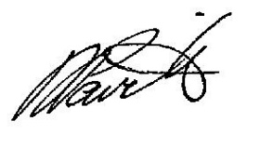
David Pavitt
Chief Development Engineer
Development Assessment and Certification

Peer endorsement
The staff responsible for the preparation of the report, recommendation, or advice to any person with delegated authority to deal with the application has no pecuniary interest to disclose in respect of the application.
The staff responsible authorised to determine the application have no pecuniary interest to disclose in respect of the application.
Signed:
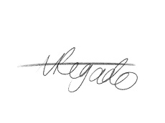
Amy Regado
Acting Chief Development Planner
Development Assessment and Certification

